Vi / Vim Editor

Vim won by a huge margin and I don’t think this is surprise to anybody. If you are new to any of the Linux text editors listed in the top 5, read the rest of the article to understand little bit more about those editors.

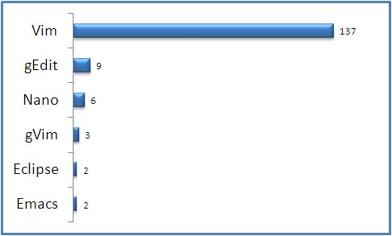

Fig: Favorite Linux Text Editor Voting Results

1. Vim Editor

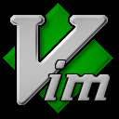

Home Page: http://www.vim.org/

Author: Bram Moolenaar

Latest Stable Version: Vim 7.2

Written in: C and Vim script

Operating System: Cross-platform (Unix, Linux and Windows)

Read more about Vim Editor at Wikipedia

Read our on-going Vi / Vim Tips and Tricks series for some awesome Vim Hacks

Vim 101 Hacks eBook contains 101 practical examples on various advanced Vim features that will make you fast and productive in the Vim editor.

2. gEdit Editor

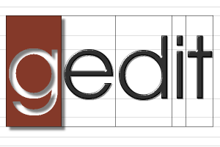

gedit is the default text editor for the GNOME desktop environment. This is a UTF-8 compatible text editor.

Home Page: http://projects.gnome.org/gedit/

Latest Stable Release: 2.26.2

Written in: C, Python

Operating System: Cross-platform

Read more about gEdit at Wikipedia

3. Nano Editor

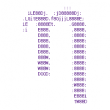

Home Page: http://www.nano-editor.org/

Latest Stable Release: 2.0.9

Read more about Nano editor

4. gVim Editor

Home Page: http://vimdoc.sourceforge.net/htmldoc/gui.html

gVim is the graphical version of the famous Vim editor

5. Emacs Editor



Home Page: http://www.gnu.org/software/emacs/

Current Stable Release: 22.3

First Release of Emacs was in the year 1976

Written in C and Emacs lisp

Operating System: Cross-platform